Instructions for Accessing Docket for
NARB v. United Airlines, DOT-OST-2018-0124

- To access the docket and related documents for this matter, go to https://www.regulations.gov/ and enter the docket number into the Search window.
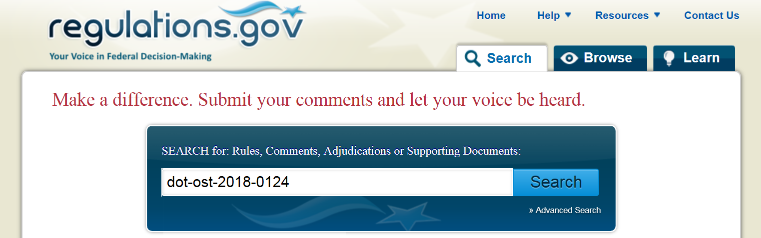

- The results of your search will appear. Since you have the specific docket number for this matter, you can click on either of the “Open Docket Folder” links to access the documents filed.
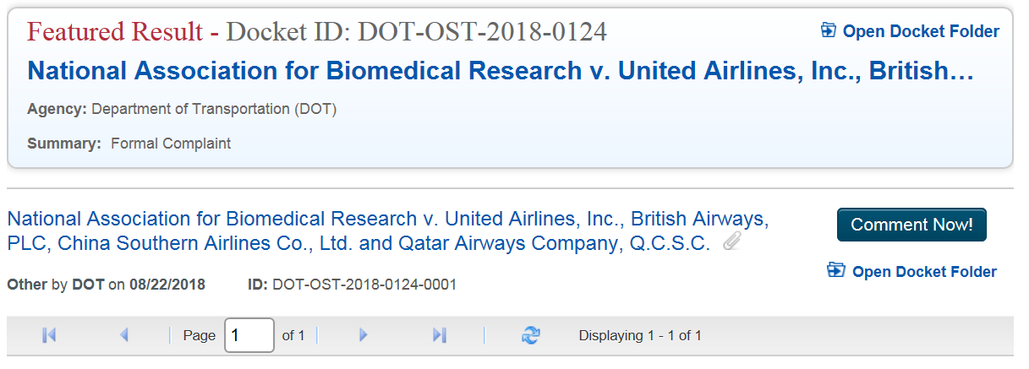

- When you open the docket folder, all submissions for this matter will appear. Click on the entry to view the full name of the document and access a pdf of the submission.
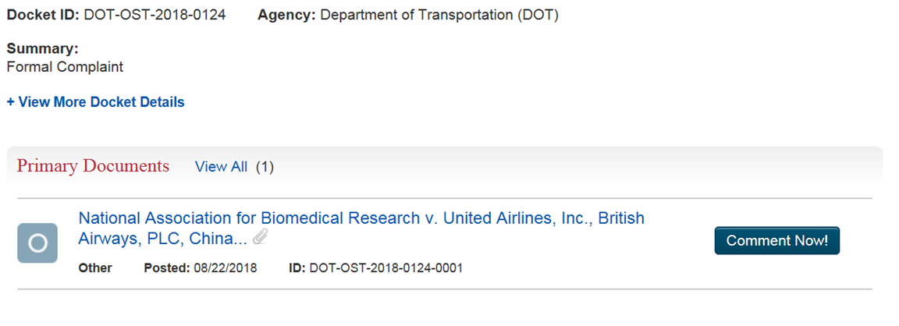
- Click on “View Attachment” to access the document(s) submitted.
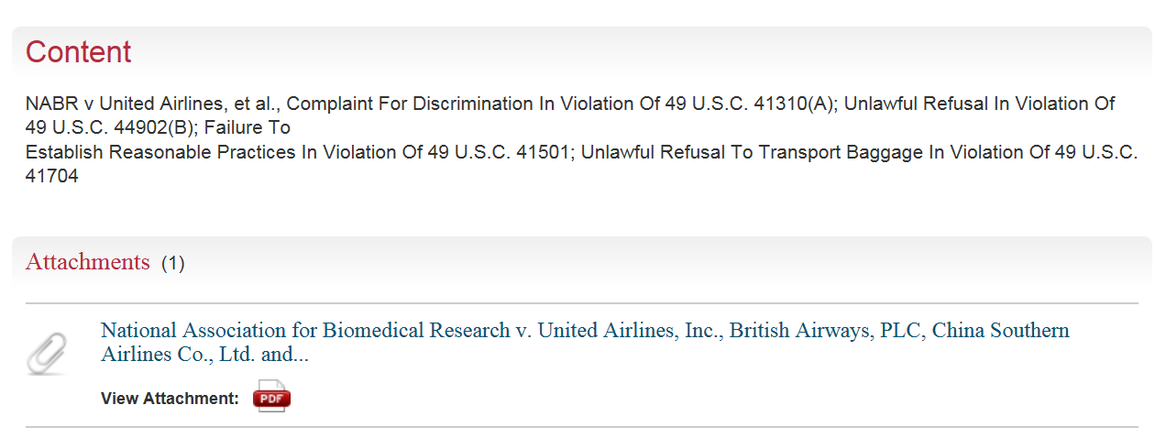

Uploading Materials to Docket
If you are adding something to the docket, you need to access the docket as described above, find the document of interest and click on the “Comment Now!” button on the right hand side of the entry.
You will be taken to the Comment Form, "Your Information" screen.
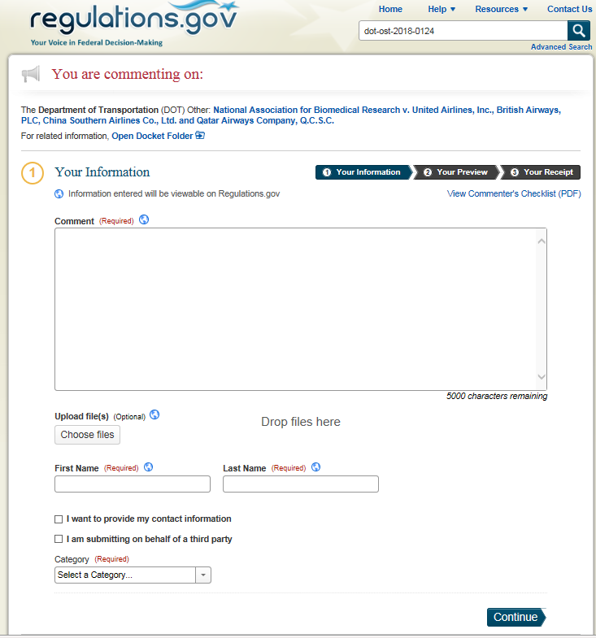
Enter your comment. If you want to attach any files, click the "Choose file(s)" button. You can attach up to 20 files, but each file cannot exceed 10MB. Valid file types include: .bmp, .docx, .gif, .jpeg, .jpg, .pdf, .png, .pptx, .rtf, .sgml, .tif, .tiff, .txt, .wpd, .xlsx, .xml. Be sure to complete any contact information fields that are required. Once you have completed this information click the "Continue" button.
Now you will see the "Your Preview" screen. This shows you how your comment will appear on Regulations.gov. Any contact information you provide that will appear on Regulations.gov is indicated as well as the information that will not appear. Once you have reviewed the information, you can either edit your comment further by clicking the "Edit" button at the bottom of the screen or submit your comment.
If you click the "Edit" button you will return to the "Your Information" screen, where you can modify the information you provided.
When you decide to submit your comment, you must first agree to the disclaimer and check the box. This will enable the "Submit Comment" button.
Once you have submitted your comment, "Your Receipt" is viewable. Be sure to save your comment tracking number in case you want to find your comment (i.e., Public Submission) once it is made viewable on Regulations.gov. Additionally, you can receive an emailed copy of your comment receipt by entering your email address in the field and clicking the "Email Receipt" button. When you have successfully emailed the comment receipt you will see the message "Your email receipt was sent successfully".
Check your inbox to ensure that you received your comment receipt.***

*** https:/www.regulations.gov/help

